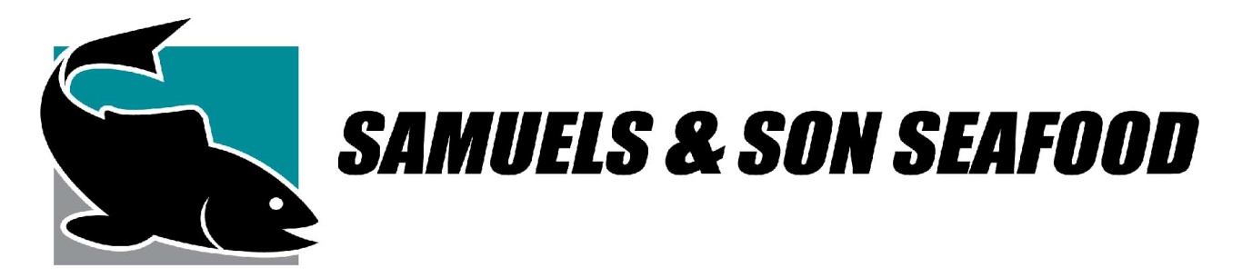
FOR IMMEDIATE RELEASE
Contact: Edward ODonnell
Director of Marketing, Samuels and Son Seafood
Office 800-580-5810
Email: Edward@samuelsandsonseafood.com
Website: Samuelsandsonseafood.com

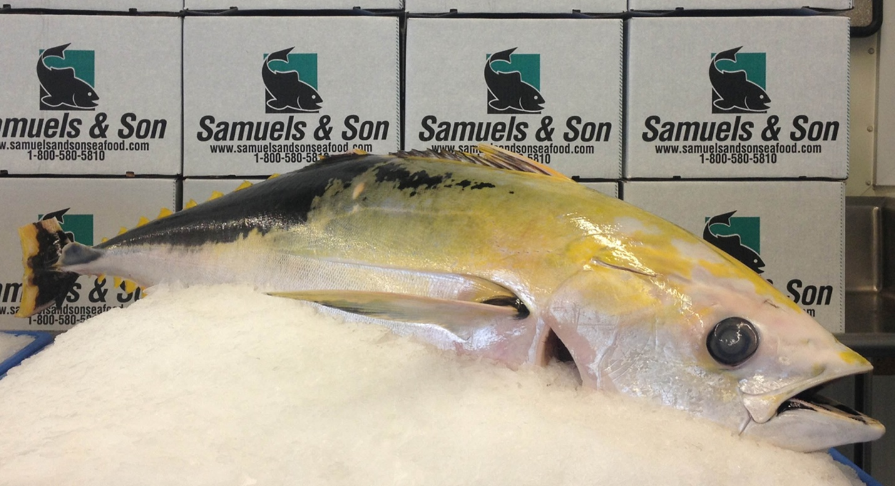

SUPER RARE GOLDEN BIG EYE TUNA
On Monday, July 8th, Samuels and Son Seafood will be bringing in one of the worlds most sought after tuna into their facility. Being the largest seafood distributor in the mid-Atlantic, Samuels has seen just about every fish from around the world as they source seafood globallay. Now, for the first time, they’ll see the coveted, Golden Bigeye Tuna.
“The last time a fish like this was caught was about five years ago, says Joseph Lasprogata,” Vice President of Samuels and Son Seafood. “Normally creatures which stand out in the ocean are eaten by predator early on. So to see a mature individual with such primitive color variation is highly unusual.”
The beautiful, 138 pound fish was long line caught off the coast of the Philippines. For generations, the Golden Bigeye Tuna has been a fish the Asian culture believes to bring good luck. This good luck will be shipped to authentic Japanese restaurant, Sushi Taro, located in Washington DC. Long-time Samuels & Son Seafood customers, Sushi Taro was ranked 36th in Forbes Magazine’s “The 100 Best U.S. Restaurants.
There are some very distinctive traits this elusive fish has. While other Bigeye Tuna have black eyes, the Golden Bigeye Tuna has very prominent white eyes. While admiring the fish, one will also notice a stunning golden colored skin.
What the fish also offers is an astonishing red colored meat that Bigeye tuna are famous for and seafood diner’s revere. Sourced from all over the world, Bigeye Tuna are sustainably harvested and loved for both cooked and raw applications.
Bigeye Tuna are sometimes hard to distinguish as they look a great deal like Yellowfin Tuna, however when a fisherman comes across the great Golden Bigeye Tuna, it’s a one in a million find.

