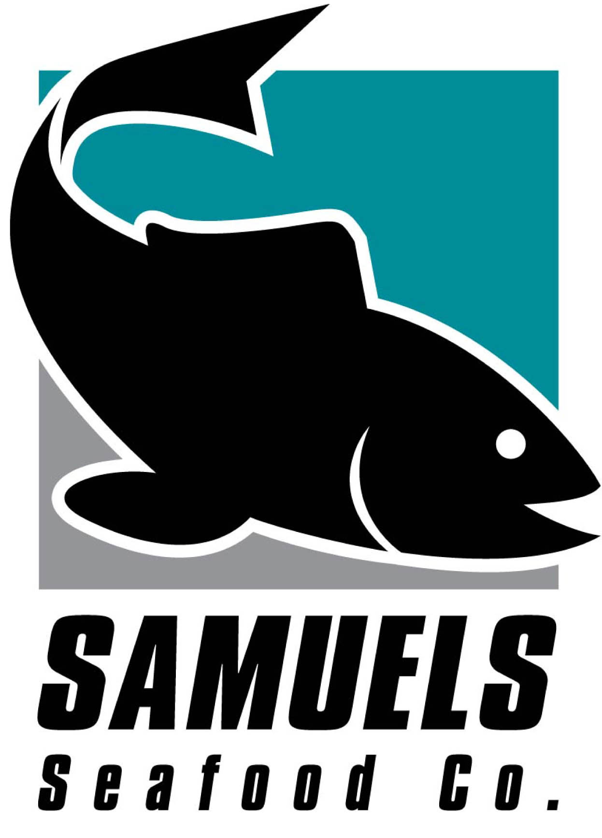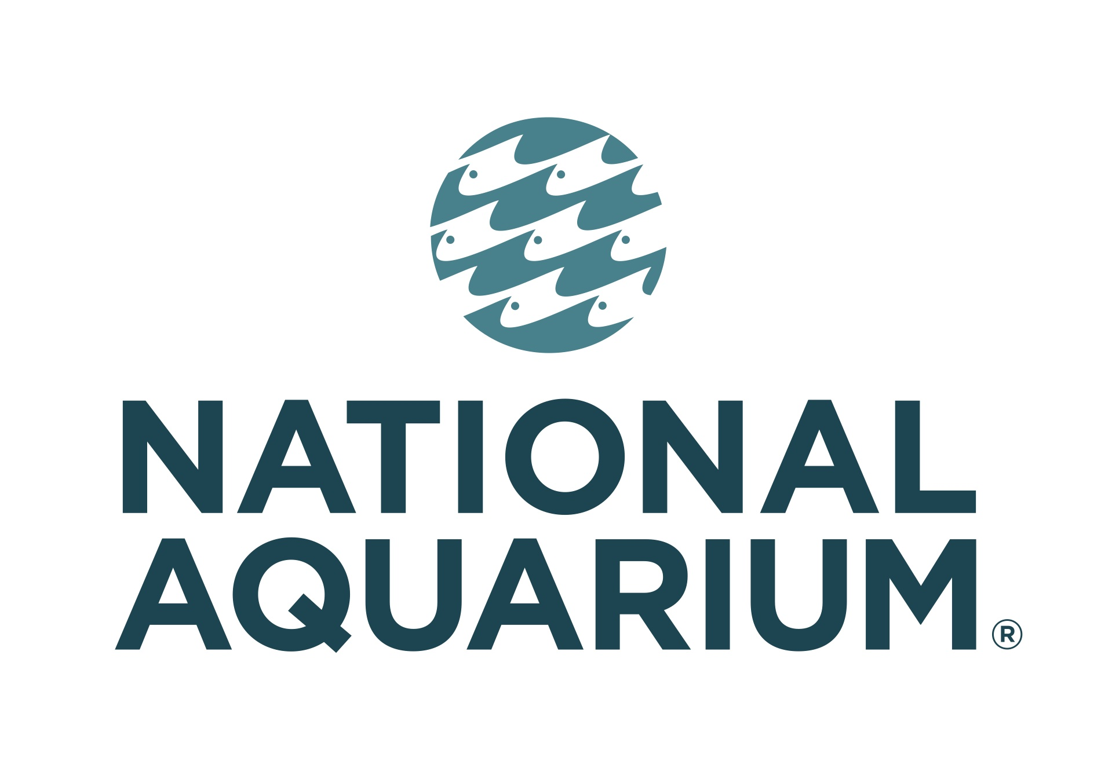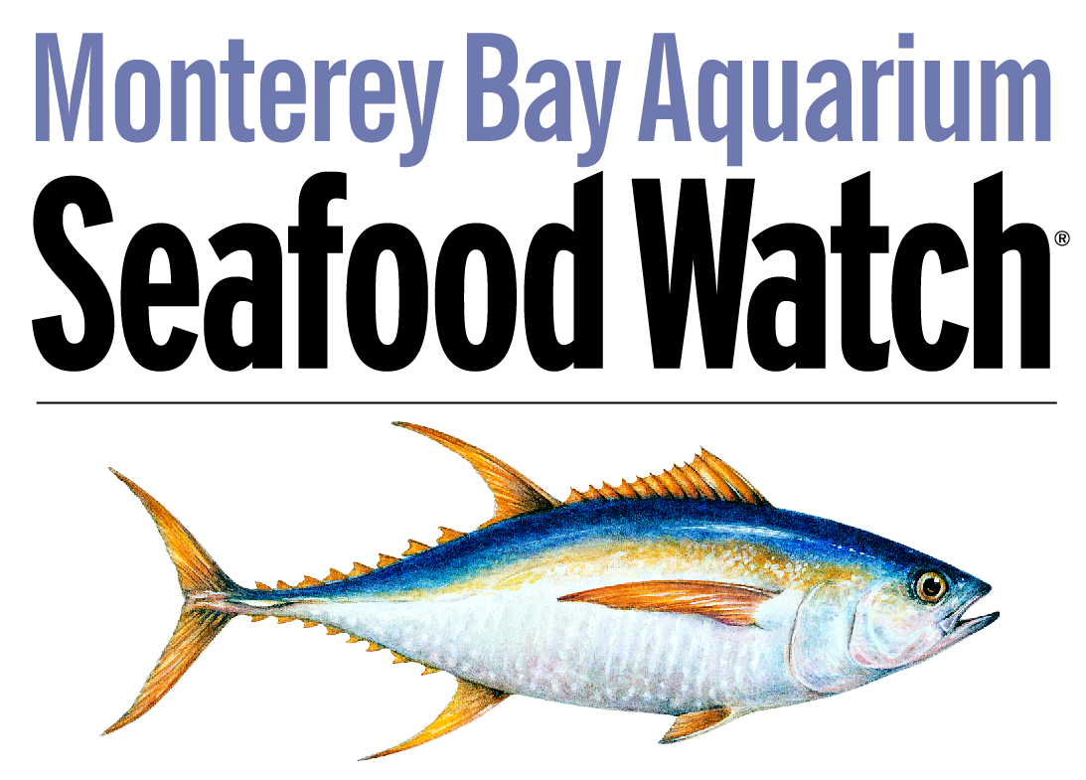

FOR IMMEDIATE RELEASE
Media Contacts:
Kate Rowe, National Aquarium
410-576-3860, krowe@aqua.org
Amy Burke Friedman, Profiles, Inc.
410-243-3790, afriedman@profilespr.com

First-ever East Coast Seafood Forum Seeks to Turn Seafood Conversations into Seafood Solutions
National Aquarium, Samuels and Son Seafood and Monterey Bay Aquarium Seafood Watch program
join forces to host day-long event

Baltimore – On Monday, October 5, the National Aquarium, in partnership with Samuels and Son Seafood and the Monterey Bay Aquarium Seafood Watch® program, will host the first-ever East Coast Seafood Forum, a one-day event that will bring together regional thought leaders from the seafood industry to re-envision the future of sustainable seafood through discussions around seafood traceability, economic sustainability and aquaculture’s role in the sustainable seafood movement.

“The goal of the East Coast Seafood Forum is to garner support for sustainable seafood through working groups targeting the needs and concerns of the complex supply chain within our Chesapeake watershed region,” said Tj Tate, National Aquarium Director of Sustainable Seafood. “This event is where we hope seafood conversations become seafood solutions.”

The Forum will take place at the National Aquarium from 8 a.m.-6 p.m. and will provide attendees with lessons, tools, connections and collaborative solutions that are currently shaping the seafood industry with emphasis placed on the Chesapeake watermen industry. The program also includes an hour-long "Ignite Session" that highlights regional leaders, their experiences, challenges and lessons related to incorporating sustainability in their businesses and what it means for the region overall.

The day’s agenda will be led by moderator Rick Moonen—celebrity chef, restaurateur and author—and includes remarks from keynote speaker Michael H. Shuman, economist, attorney, author, entrepreneur and globally recognized expert on community economics; Spike Gjerde, culinary champion of the Chesapeake and James Beard Award winner; Barton Seaver, chef, author and seafood visionary; Jeff Morgan, pioneer in cocoa sustainability at Mars, Inc.; and many others.

To purchase tickets or for more information on the East Coast Seafood Forum as well as the National Aquarium’s sustainable seafood program, visit aqua.org/seafood.

National Aquarium
The National Aquarium is a nonprofit organization whose mission is to inspire conservation of the world’s aquatic treasures. It champions environmental initiatives by engaging with visitors, volunteers, education groups and schools to actively participate in the preservation of the world’s natural resources and living systems. The National Aquarium delivers meaningful experiences through its living collections; science-based education programs and hands-on experiences in the field from the Chesapeake Bay to Costa Rica; and partnerships and alliances with like-minded organizations around the world. For more information on the National Aquarium, visit www.aqua.org.

Samuels and Son Seafood
Samuels and Son Seafood is dedicated to serving chefs, retailers and restaurants throughout the Mid-Atlantic, Mid-West and West Coast regions with premium fresh and frozen seafood and incredible customer service. Samuels and Son Seafood has been at the forefront of sustainability since their inception. Sustainability is ingrained in Samuels business philosophy to ensure a sustainable future. Purchasing decisions, employee training and packaging considerations all take a sustainable and ecofriendly approach. Samuels and Son Seafood is a family owned and operated company that has been providing exceptional and sustainable seafood for over 125 years. For more information on Samuels and Son Seafood, visit www.samuelsandsonseafood.com.

Monterey Bay Aquarium Seafood Watch program
The mission of the nonprofit Monterey Bay Aquarium is to inspire conservation of the oceans. Seafood Watch’s respected science-based recommendations help individuals and businesses make seafood choices that support healthy oceans. For more information on the Seafood Watch program, visit www.seafoodwatch.org.

###

